Superposition Graphs

Complex waves are created by adding simple waves.

1. Draw the wave pattern that results when the 2 given waves meet. 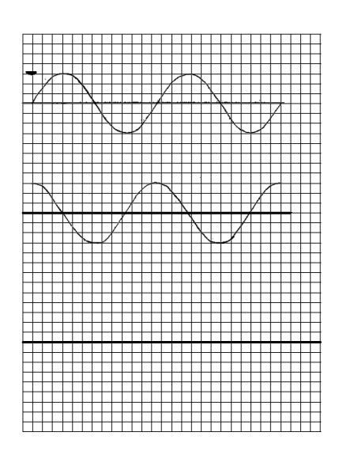
2. Draw the wave pattern that results when the 2 given waves meet.

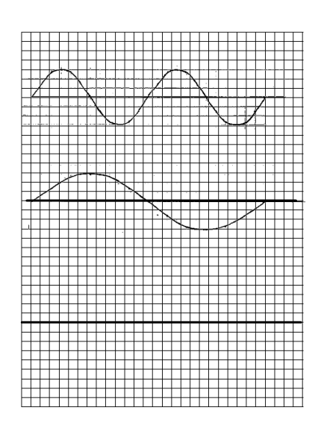

3. Create a standing wave pattern from the given traveling wave. Label nodes and antinodes on the standing wave you create. Mark ¼ , ½ and 1 full wavelength of the standing wave.